TW - Autodispatch procedure

DOCUMENT HISTORY
Vers. | Date | Author | Version description | Status
1.0 |  |  | First version | A
Status: R = Redaction in progress, C = Comments awaited, A = for Approval, V = Validated, O = Obsolete

DOCUMENT VALIDATION
Action | Date | Name | Title
Redaction
Update
Validation

CLASSIFICATION and DISTRIBUTION
☐  Public  (for everyone) | ☒  Internal  (for company) | ☐  Restricted  (for a team) | ☐  Confidential  (for listed people)
☐ Contains personal information in the document body
Internal: TeamWork internal release only
Restricted: limited to identified stakeholders
Confidential: distribution limited to a list of named persons + specific protection mechanism

Distribution list
To define if Restricted or Confidential document
Contents
1 Context 3
1.1 Document objective 3
1.2 Definitions 3
2 Global process 4
2.1 Process steps 4
3 Architecture 5
3.1 Diagram 5
4 Detailed process 6
4.1 Autodispatch detailed workflow 6
5 Maintenance / Scaling 8
5.1 Maintenance 8

Context

Document objective
This document serves as a comprehensive guide for maintaining and scaling the autodispatch bot. It provides step-by-step instructions on scheduling and automation, training and updating the Machine Learning Model, scaling for new customers and employees, monitoring and troubleshooting.

This document also made for individuals who are familiar with AWS services, including Lambda, Sagemaker AI, DynamoDB, EventBridge, S3, and CI/CD pipelines.

Definitions

Global process

Process steps

Phase 3 To be developed

Figure 2.1 Autodispatch workflow diagram
(Author: BOSQUILLON Vincent)

Architecture

Diagram
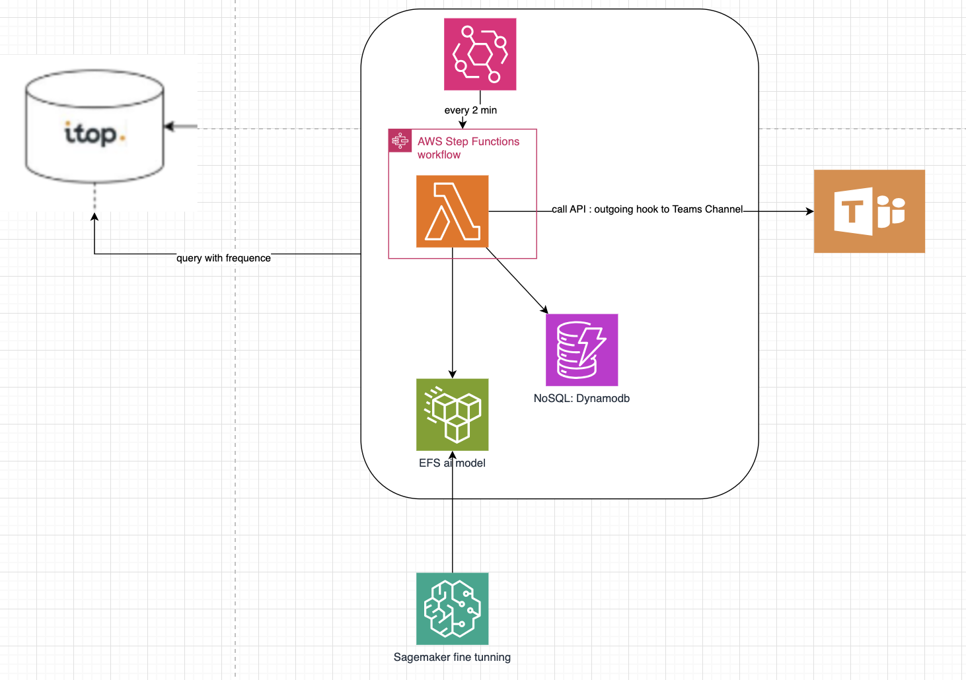

Architecture diagram explanation:
- AWS Step Functions and Lambda for orchestration and execution
- DynamoDB as the database
- CI/CD pipeline via AWS SAM and GitHub Actions
- EventBridge to schedule time to run and execution
- Sagemaker Jupyter Notebooks for building Machine Learning prediction model.

Detailed process

Autodispatch detailed workflow
The autodispatch bot operates on a 2-minute interval, continuously retrieving newly created tickets assigned to the [GDC_WW]_OneOps team. The workflow consists of the following steps:

- Fetching New Tickets:
  - Every 2 minutes, the bot retrieves tickets that have been newly created and assigned to [GDC_WW]_OneOps.

- Processing & Prediction:
  - The bot analyzes each ticket and predicts the most suitable team to handle it based on historical data and machine learning models.

- Posting to Teams Channel:
  - After determining the appropriate team, the bot posts the ticket details in the corresponding Microsoft Teams channel, categorized by Organization and Team.
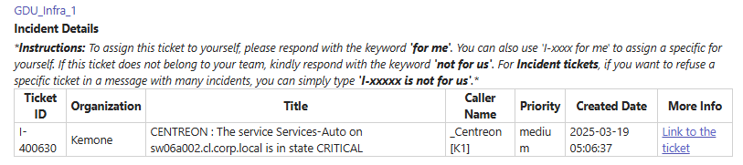

- Consultant Assignment:
  - If a consultant from the predicted team replies with "for me", the bot assigns the ticket to them automatically on iTop:
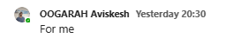
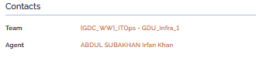

- Consultant Rejection & Manual Reassignment:
  - If a consultant responds with "not for us", the bot:
    - Notifies the OneOps channel that the ticket was rejected.
    - Reposts the ticket in OneOps, alerting all available consultants for manual reassignment.
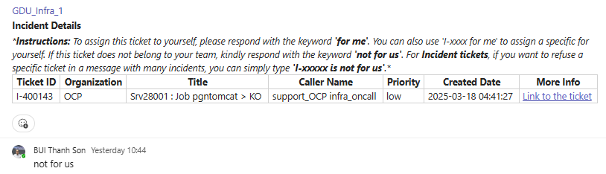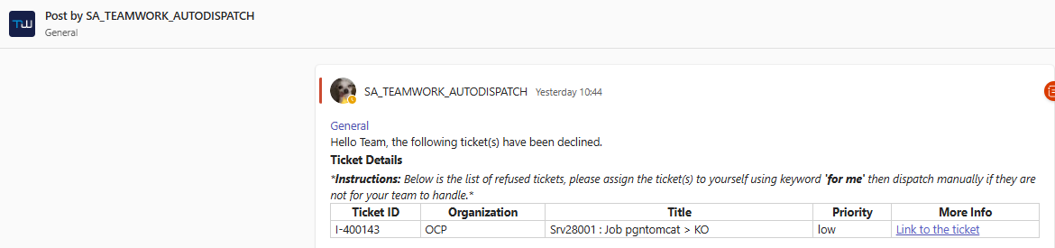

Maintenance / Scaling

Maintenance
    - Autodispatch deploy location
- The bot is currently deployed in LZV2 (accessible through MyApps)– in AWS account TEAMWORK - GDC – PROD.

- Autodispatch is running using Lambda service (Function name: autodispatch_PRD) and EventBridge (Rule name: AutoDispatchScheduler) - scheduled to run every 2 minutes for weekdays, from 2am CET – 6pm CET (in VN and FR shift currently).

- All data about teams, consultants, ticket data etc. are stored in DynamoDB (all using tables are put in highlighted red box):
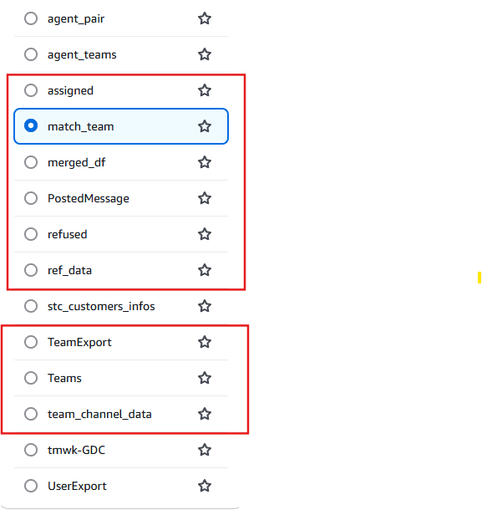
- The training model is put in SageMaker Notebooks (instances: autodispatchML) with Jupyter Notebook: incident_prediction.ipynb
- The trained model and configurations are stored in S3 Bucket (itop-fetching/models/), ready for execution.
    - Refresh token rotation
The refresh token is being used to grant permission to post tickets into Team channels. It is stored in /itop/access_token. The token has expiration duration of 3 months and we need to renew it every 3 months.

If you see the bot is not dispatching any new ticket, possibly the token was expired.
How to rotate refresh token:
1. Clone the code from Github Organization tmwk-GDC, repository Autodispatch_itop.
2. Go to Azure portal à App registration à AutoTicket
3. Copy Client ID and Tenant ID to the code, then run the script:
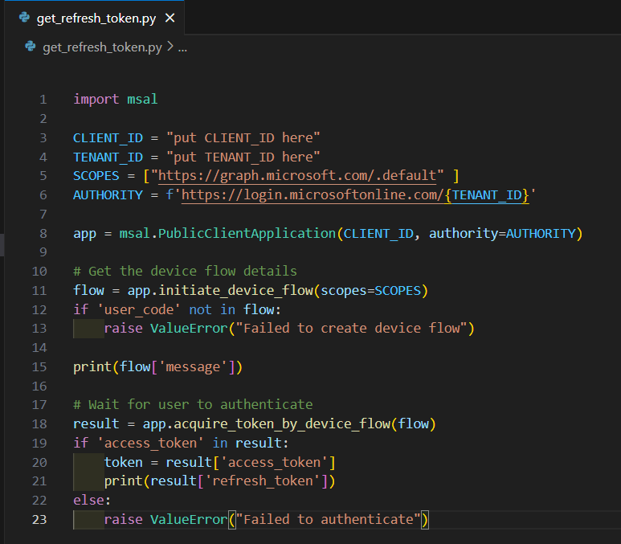
It will ask you to access a website with a code, access the website and insert the provided code. Login using Autodispatch credentials (sa_teamwork_autodispatch@teamwork.net). After successful login, turn back to the code and get the new refresh token and update it on ParameterStore /itop/access_token
4. Wait until the next scheduled run for autodispatch to get the updated token or you can disable/enable the rule to take effects.

    - Clean up data to prevent slow/duplicate posting
The autodispatch bot processes a large volume of tickets daily and stores ticket-related data in the PostedMessage table within DynamoDB. However, if the number of stored tickets exceeds 300, the bot may experience:
- Slower execution times due to increased data retrieval and processing overhead.
- Duplicate postings caused by insufficient timeout handling.
Solution: Data Cleanup Strategy
To maintain optimal performance and prevent issues, you should clean data in tables PostedMessage, ref_data to ensure consistent dispatching speed for the bot. Keep at least 1 record in each table to prevent missing columns in tables.

  - Scaling/Improving predictions

    - Adding new customer channel
Autodispatch bot will post tickets to customer channels based on DynamoDB table match_team,
If there is a new customer, create new item in this table:

To obtain the Team_ID, follow these steps:
- Extract Group ID from the Customer Channel Link:
- Open the Microsoft Teams channel link for the customer.
- Locate the Group ID in the URL.
- Store the Group ID in the Database: Insert the extracted Group ID into the TeamID column of the relevant table.
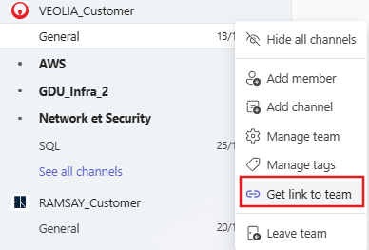

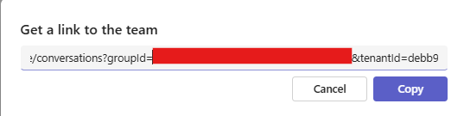
PairName: Find the corresponding organization on iTop, then put it to PairName
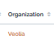
Team_Name: get name on the Teams channel
Team_Name_nocustomer: use the name on the Teams channel, exclude _Customer
Confirm ‘Create Item’ and done for updating new Customer to autodispatch database.

    - Adding new consultant
To add new consultant following these steps,
1. locate to DynamoDB table merged_df:

2. Create items, fill in data for each column with following instructions:
Person: you need to get person id from iTop (could be on iTop tickets details)
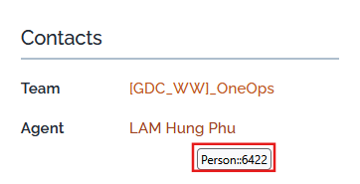
Agent_MTeams: get the name from Teams


Login & PairName_x & Person->Organization: these values are not being used for now, so leave it blank or fill in whatever.
Person_Full name: get the name from iTop
After done fill in the inputs, click on ‘Create item’ and complete the steps.

    - Adding new team on iTop

To add new/update team from iTop, locate to DynamoDB table TeamExport and following these steps:
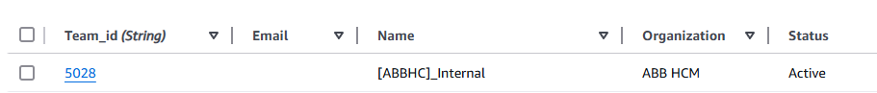
- Create item, fill in the data:
  - Team_id: get the teamid from iTop, hover over the team link to view the id:
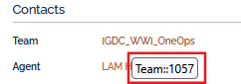
  - Email , Organization, Status: leave blank or fill in whatever
  - Name: get exactly name of the team on iTop:
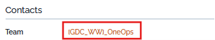

    - Troubleshooting: Bot Not Posting Tickets After Adding a New Customer
If the autodispatch bot fails to post a ticket despite correctly predicting the handling team and updating the new customer in the database, the issue is likely due to a name mismatch between:
- The Microsoft Teams channel name inside the Customer channel
- The Team name recorded in iTop

Solution: Update the Team Mapping in DynamoDB
- Verify the Mismatch:
  - Check if the predicted team exists in iTop but is missing or incorrectly named in the Teams channel.
- Update the Mapping in DynamoDB:
  - Navigate to the DynamoDB table team_channel_data.
  - Create item and input the values as follows:
    - id: Find the consecutive number and add up.
    - Channel_Name: The channel name that was mismatched on Teams Customer channel.
    - Team_Name: the team’s name on iTop that needs to match.
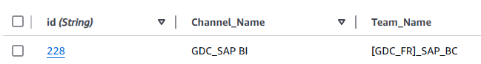

    - Improve/ Update prediction results for new Teams/Customers
To enhance prediction accuracy and update new Teams/Customers for the machine learning model, follow these steps:
1. Update the Training Dataset
- The dataset is stored in S3 bucket: itop-fetching/dataset/Incidentdatafull.xlsx.
- Download and open the Excel file to modify the training data.
- The "Ref" column is not important—keep it as an index.

2. Synthesizing Ticket Data for New Organizations
To improve model accuracy, especially for tickets frequently misclassified or dispatched to the OneOps channel with low confidence(probability), you should:
- Add more training data that resemble existing tickets but are not exact duplicates.
- Modify minor details such as hostnames, service names, or wording while keeping the core structure similar.

Example of Synthetic Data Creation
Original Ticket:
I-359158 CENTREON: The service Uptime on AZ-PO-POP-CI1.bouvard.ad is in state CRITICAL Biscuits Bouvard [GDC_WW]_SAP_BC
Look for similar history tickets in the dataset (Incidentdatafull.xlsx), if there were many teams involved in resolving the ticket, it may confuse the predictions (which is causing low probability), you need to align with single team that responsible for handling this kind of ticket only.
You can generate more variants from the ticket with low-probability like below:
Ref | Title | Organization->Name | Team->Name
I-359159 | CENTREON: The service Uptime on AZ-PO-POP-CI2.bouvard.ad is in state CRITICAL | Biscuits Bouvard | [GDC_WW]_SAP_BC
I-359160 | CENTREON: The service CPU Load on AZ-PO-POP-CI1.bouvard.ad is in state WARNING | Biscuits Bouvard | [GDC_WW]_SAP_BC

Save & Retrain the Model
- Save and overwrite the updated Excel file in the S3 bucket.
- Access SageMaker Notebook Instances.
- Open autodispatchML and launch Jupyter Notebook to retrain the model with the updated dataset.
- Open Jupyter lab, clear the files as shown in image:
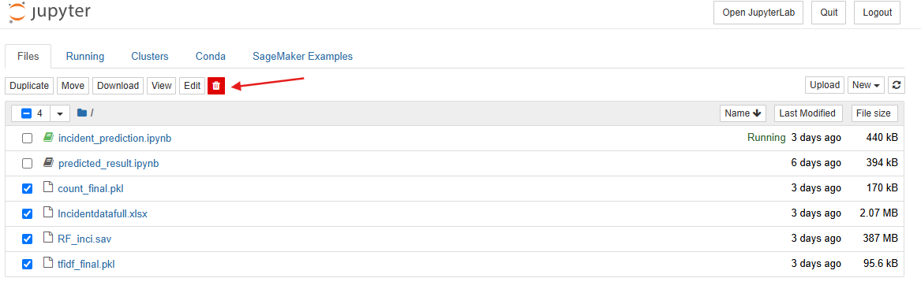
- Next, click to open incident_prediction.ipynb, then click on Cell>Run all:
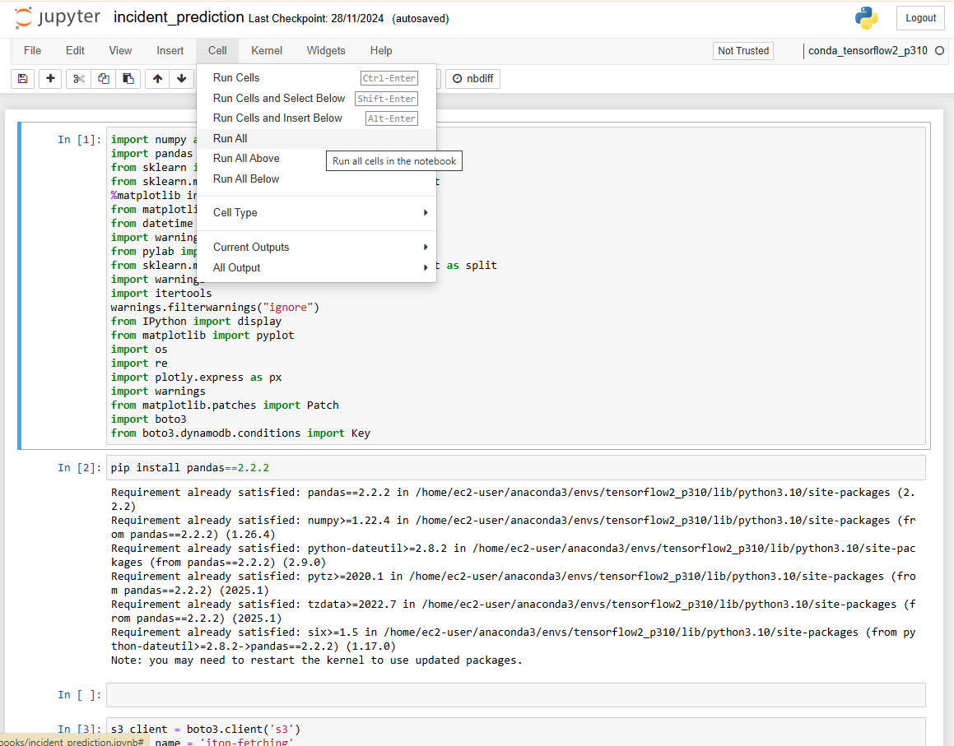
- If this is the first run, you can face this kind of error,
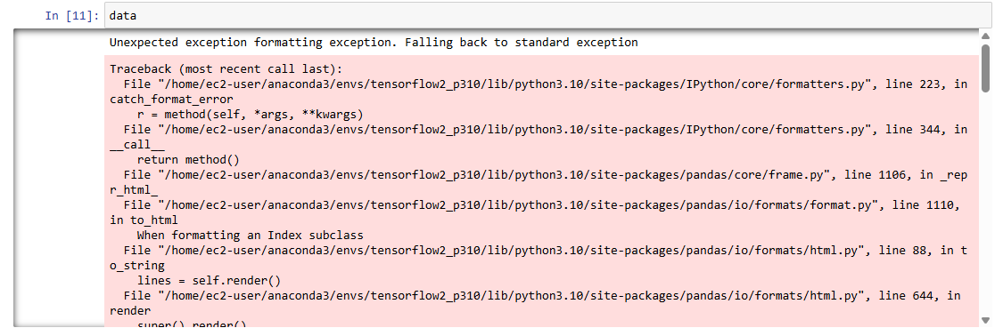
- Simply click on Kernel > Restart & Run All
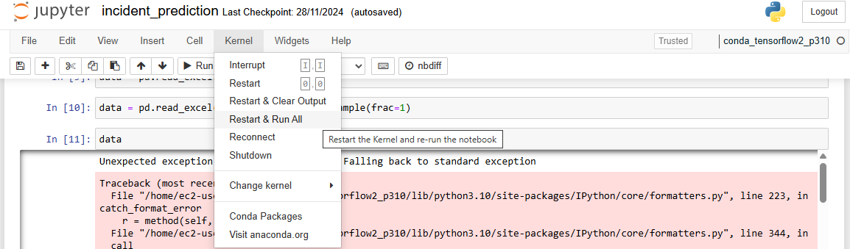
- After that, the notebook will rerun and yield prediction results in last parts of the notebook. The model will be updated with new dataset.

